https://www.geeksforgeeks.org/quick-sort-algorithm/

How does QuickSort Algorithm work?

QuickSort works on the principle of divide and conquer, breaking down the problem into smaller sub-problems.

There are mainly three steps in the algorithm:
- Choose a Pivot: Select an element from the array as the pivot. The choice of pivot can vary (e.g., first element, last element, random element, or median).
- Partition the Array: Rearrange the array around the pivot. After partitioning, all elements smaller than the pivot will be on its left, and all elements greater than the pivot will be on its right. The pivot is then in its correct position, and we obtain the index of the pivot.
- Recursively Call: Recursively apply the same process to the two partitioned sub-arrays (left and right of the pivot).
- Base Case: The recursion stops when there is only one element left in the sub-array, as a single element is already sorted.

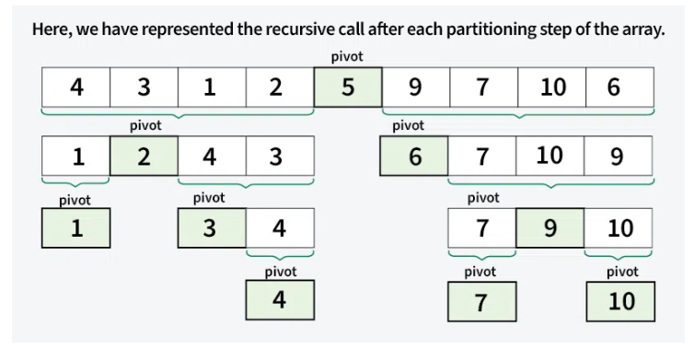

To sort an array efficiently using the Quick Sort algorithm with the pivot as the leftmost element.
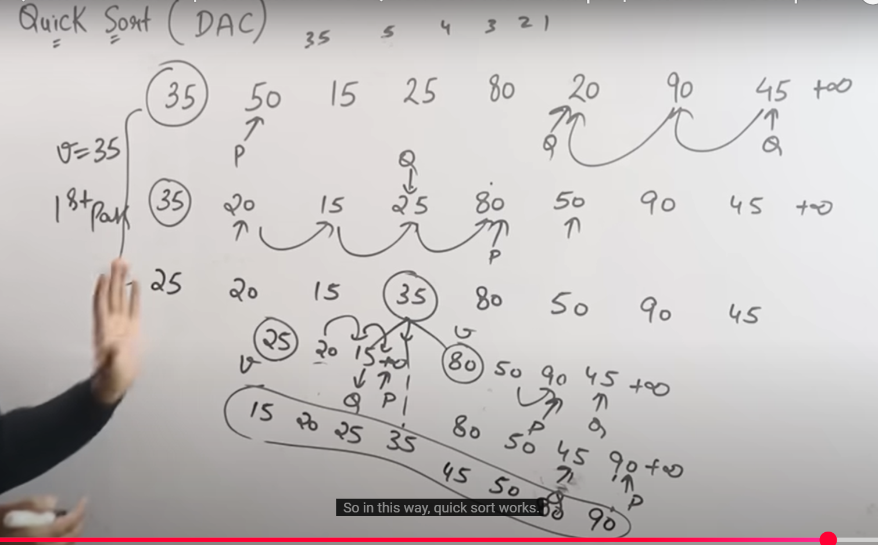

https://www.youtube.com/watch?v=tWCaFVJMUi8

Quick Sort Algorithm with Pointer p, q and Leftmost Pivot

Purpose:
To sort an array efficiently using the Quick Sort algorithm with the pivot as the leftmost element.

Input:
- An array arr[] of length n.

Output:
- A sorted array in ascending order.

Algorithm:

1. Quick Sort Algorithm (arr[], low, high)
- Steps:
  - If low < high:
    - Partition the array using the partition() method.
    - Recursively apply Quick Sort to:
      - Left subarray: arr[low] to arr[q - 1]
      - Right subarray: arr[q + 1] to arr[high]

2. Partition Algorithm Partition (arr,low,high)
- Purpose: Partition the array such that elements smaller than pivot go to the left, and elements larger go to the right.
- Steps:
  - Choose the pivot as the leftmost element (arr[p]).
  - Initialize:
    - p as the start index.
    - q as the end index.
  - Traverse until p < q:
    - Increment p until arr[p] > pivot.
    - Decrement q until arr[q] < pivot.
    - If p < q, swap arr[p] and arr[q].
  - Swap arr[low] (pivot) with arr[q] to place the pivot at the correct position.

2. Quick Sort Algorithm
- Steps:
  - If low < high:
    - Partition the array using the partition() method.
    - Recursively apply Quick Sort to:
      - Left subarray: arr[low] to arr[q - 1]
      - Right subarray: arr[q + 1] to arr[high]

Pseudocode:

Partition Pseudocode
PARTITION(arr, low, high)
pivot ← arr[low]
p ← low + 1
q ← high

while p ≤ q do
while p ≤ high AND arr[p] ≤ pivot do
p ← p + 1
end while

while q ≥ low AND arr[q] > pivot do
q ← q - 1
end while

if p < q then
SWAP(arr[p], arr[q])
end if
end while

SWAP(arr[low], arr[q])
return q

Quick Sort Pseudocode
QUICK_SORT(arr, low, high)
if low < high then
q ← PARTITION(arr, low, high)

QUICK_SORT(arr, low, q - 1)
QUICK_SORT(arr, q + 1, high)
end if

public class QuicSortV1 {

// Partition method to place pivot at correct position
public static int partition(int arr[], int low, int high) {
int pivot = arr[low]; // Pivot as the leftmost element
int p = low + 1;
int q = high;

while (p <= q) {
// Move p to the right while arr[p] <= pivot
while (p <= high && arr[p] <= pivot) {
p++;
}

// Move q to the left while arr[q] > pivot
while (q >= low && arr[q] > pivot) {
q--;
}

// Swap arr[p] and arr[q] if p < q
if (p < q) {
swap(arr, p, q);
}
}

// Swap pivot with arr[q] to place pivot in the right position
swap(arr, low, q);
return q;
}

// Quick sort method
public static void quickSort(int arr[], int low, int high) {
if (low < high) {
int q = partition(arr, low, high);

// Sort left and right subarrays recursively
quickSort(arr, low, q - 1);
quickSort(arr, q + 1, high);
}
}

// Swap method
public static void swap(int arr[], int i, int j) {
int temp = arr[i];
arr[i] = arr[j];
arr[j] = temp;
}

// Main method
public static void main(String[] args) {
int arr[] = {10, 80, 30, 90, 40, 50, 70};
int n = arr.length;

System.out.println("Original Array:");
printArray(arr);

quickSort(arr, 0, n - 1);

System.out.println("\nSorted Array:");
printArray(arr);
}

// Print array method
public static void printArray(int arr[]) {
for (int i : arr) {
System.out.print(i + " ");
}
System.out.println();
}

}

run:
Original Array:
10 80 30 90 40 50 70

Sorted Array:
10 30 40 50 70 80 90
BUILD SUCCESSFUL (total time: 0 seconds)

Complexity Analysis of Quick Sort
Time Complexity:
- Best Case: (Ω(n log n)), Occurs when the pivot element divides the array into two equal halves.
- Average Case (θ(n log n)), On average, the pivot divides the array into two parts, but not necessarily equal.
- Worst Case: (O(n²)), Occurs when the smallest or largest element is always chosen as the pivot (e.g., sorted arrays).
Auxiliary Space: O(n), due to recursive call stack
Please refer Time and Space Complexity Analysis of Quick Sort for more details.

Advantages of Quick Sort
- It is a divide-and-conquer algorithm that makes it easier to solve problems.
- It is efficient on large data sets.
- It has a low overhead, as it only requires a small amount of memory to function.
- It is Cache Friendly as we work on the same array to sort and do not copy data to any auxiliary array.
- Fastest general purpose algorithm for large data when stability is not required.
- It is tail recursive and hence all the tail call optimization can be done.

Disadvantages of Quick Sort
- It has a worst-case time complexity of O(n2), which occurs when the pivot is chosen poorly.
- It is not a good choice for small data sets.
- It is not a stable sort, meaning that if two elements have the same key, their relative order will not be preserved in the sorted output in case of quick sort, because here we are swapping elements according to the pivot’s position (without considering their original positions).

Applications of Quick Sort
- Efficient for sorting large datasets with O(n log n) average-case time complexity.
- Used in partitioning problems like finding the kth smallest element or dividing arrays by pivot.
- Integral to randomized algorithms, offering better performance than deterministic approaches.
- Applied in cryptography for generating random permutations and unpredictable encryption keys.
- Partitioning step can be parallelized for improved performance in multi-core or distributed systems.
- Important in theoretical computer science for analyzing average-case complexity and developing new techniques.

